# Sample template file of Using templdocx library

|  |  |  |  |
| --- | --- | --- | --- |
| Created by: | John Doe | Created on: | 2025-05-01 |

## Description

We can build result values in functions
or use existing. It depends on our needs. For sure we can
pass params to functions

## Events chronology

|  |  |
| --- | --- |
| Date and time | Event’s description |
| 2025-06-02 12:23 | John made some action |
| 2025-06-02 12:25 | Mr Doe made another action |

## Attachments

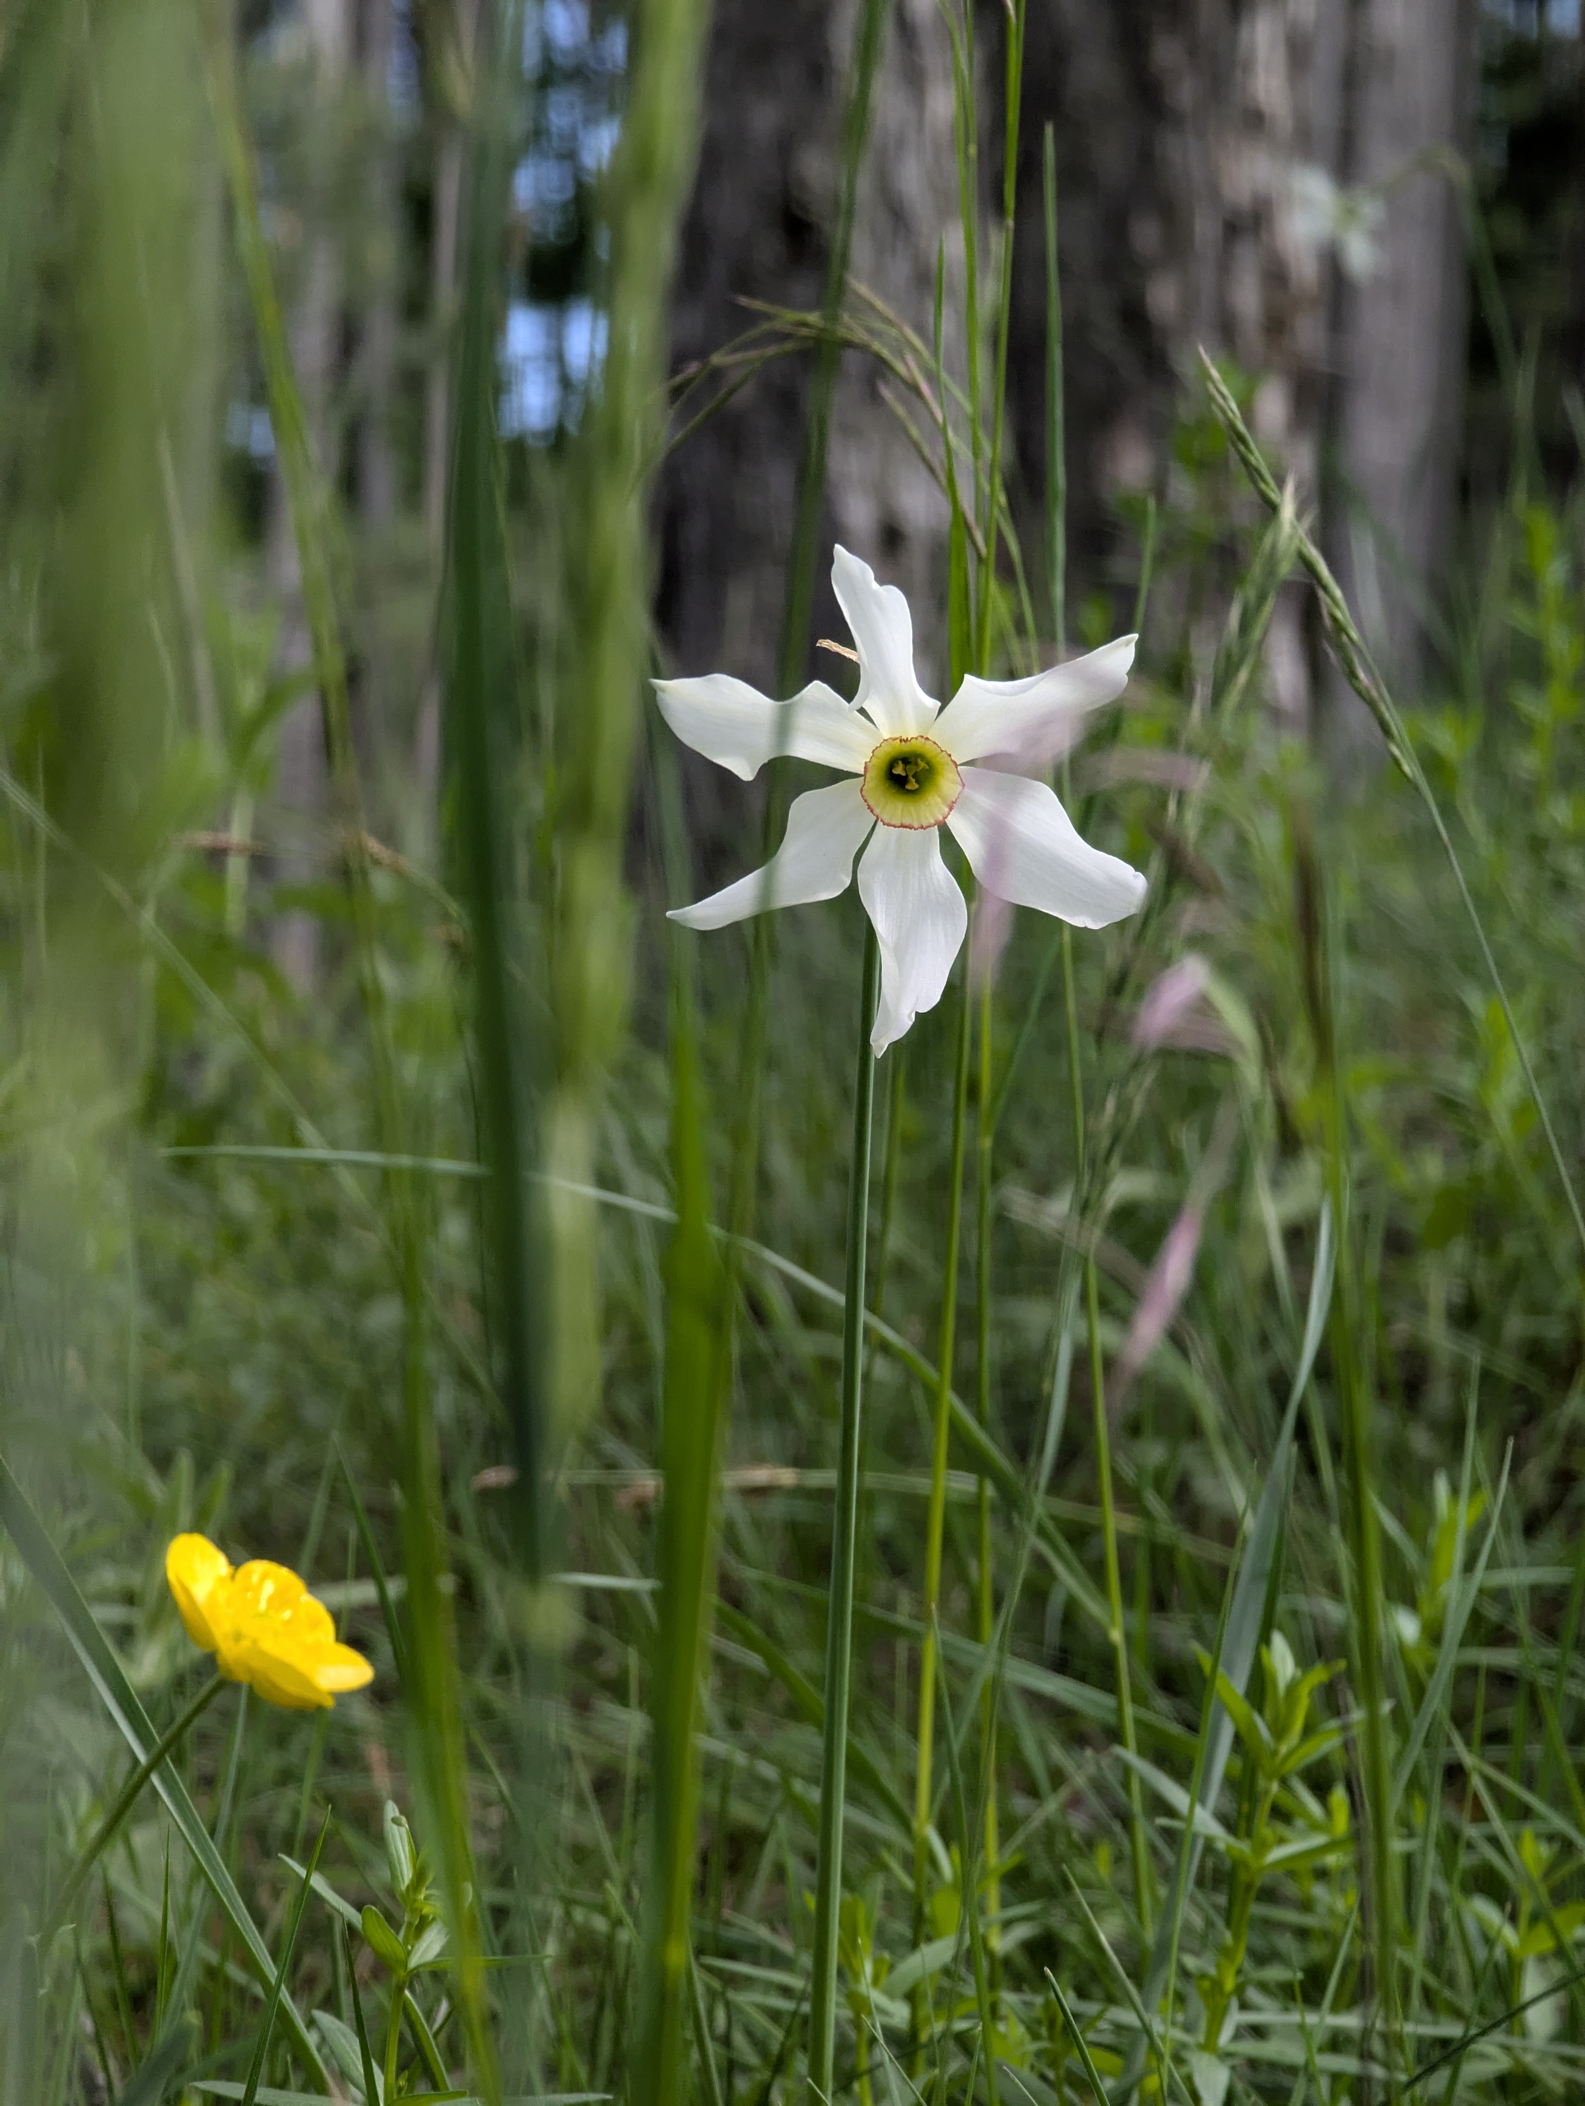

first



second